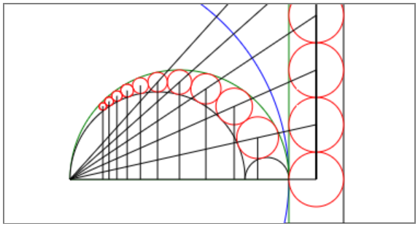

# Circle Inversion & Pappus Chain

Su Kara

Advisor: James G. Wenk

Grade: 8

Newhart Middle School

Mission Viejo, CA

Presented at OCSEF

March 12-14, 2018

# Abstract

Arbelos is the region bounded by the three semicircles in the figure below. The semicircles share the same diameter line,and they’re all tangent to each other. Arbelos was named for its similarity to a knife used by shoemakers in ancient times (ScienceBuddies, 2017).

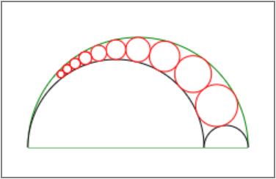

Pappus chain is the chain of circles inscribed in the arbelos. Pappus of Alexandria proved a theorem in the 4th century A.D., which states that the height from the center of the *nth* inscribed circle is equal to *n* times the diameter of that circle.

Pappus used Euclidean geometry to prove his theorem. Jakob Steiner invented *circle inversion* in the 19th century, which made life easier to prove complex theorems. My objective is to develop an open-source software application to simulate circle inversion and prove Pappus' theorem.

Table of Contents

Problem 1

Introduction 1

Inversion of a Point 1

Inversion of a Circle 2

Original Circle Not Passing Through the Center of the Inversion Circle 4

Original Circle Passing Through the Center of the Inversion Circle 5

Pappus Chain 9

Inversion of a Pappus Chain 10

Homothety 11

Materials & Methods 12

Results 14

Inversion of a Point 14

Inversion of a Circle 15

Pappus Chain 16

Discussion 17

Conclusion 19

Further Research 20

Acknowledgements 20

References 20

# Problem

Prove that the height from the center of the *nth* inscribed circle in the Pappus chain is equal to *n* times the diameter of that circle by using *circle inversion*.

# Introduction

Circle inversion can be used to convert geometric figures into other forms. Inverted circles can simplify a difficult problem in a different perspective (Tom Davis, 2011).

## Inversion of a Point

Inversion transforms a point *P* to a point *P′* with respect to an inversion circle. An inversion circle can be described by its inversion center *O* and inversion radius *r*. For *P′* to be the inverse of point *P*, the points *O*, *P*, and *P′* must be on the same line, and *OQ* and *QP′* must be perpendicular to each other (WolframMathWorld, 2017).

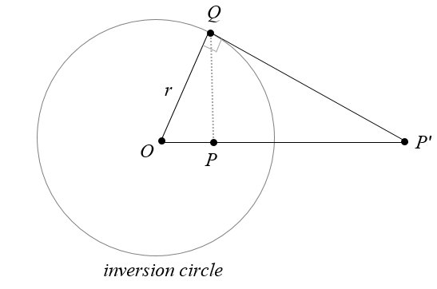

Since triangle *OPQ* is similar to triangle *OQP′*, we can suggest the proportion:

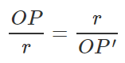 => 

If the original point *(x,y)* is inverted with respect to an inversion circle with center *(x0,y0)* and radius *r*, the inverted point (*x′,y′*) can be calculated as follows:

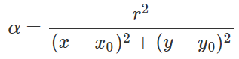





If the original point is on the circumference of the inversion circle, its inverse will be itself. Since *OP* will be equal to *r*, *OP*′ must be equal to the same to satisfy the equation *OP.OP′=r2*.

If the original point is at the center of the inversion circle, it cannot be inverted. Since *OP* will be zero, *OP′* will be undefined in the equation *OP.OP′=r2*.

## Inversion of a Circle

Inversion of a circle transforms all points on the original circle with respect to an inversion circle. The outcome will be a circle or a line (Tom Davis, 2011).

Possible scenarios for circle inversion:

1. If the original circle doesn’t pass through the center of the inversion circle, it will be inverted to a circle.
   1. If the original circle is inside the inversion circle, the inverted circle will be outside.
   2. If the original circle is outside the inversion circle, the inverted circle will be inside.
   3. If the original circle intersects the inversion circle, the inverted circle intersects the inversion circle at the same points.
   4. If the original circle is orthogonal to the inversion circle, it will be inverted onto itself.
2. If the original circle passes through the center of the inversion circle, it will be inverted to a line.
   1. If the original circle passes through the inversion circle at two points *P* and *Q*, its inversion will be the line passing through *P* and *Q*.
   2. If the original circle is internally tangent to the inversion circle, its inverse will be the line externally tangent to the inversion circle.
   3. If the original circle is inside the inversion circle, its inverse will be a line outside the inversion circle.

### Original Circle Not Passing Through the Center of the Inversion Circle

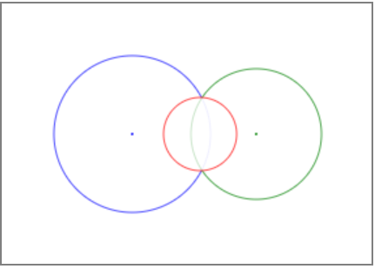

If the inversion circle (blue) has a center *(x0,y0)* and a radius r0, and the original circle (green) has a center *(x,y)* and a radius *r*, the inverted circle (red) will have a center *(x′,y′)* and a radius *r′* as below (WolframMathWorld, 2017):

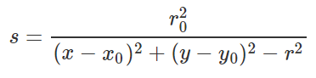







### Original Circle Passing Through the Center of the Inversion Circle

If the original circle passes through the center of the inversion circle, the inversion will be a line rather than a circle. If the circles intersect, the inverted line will pass through the intersection of the two circles (AmBrSoft, 2016).

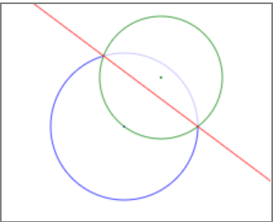

Equations of the two intersecting circles:





Distance between the centers of the two circles:

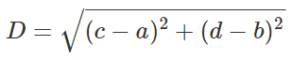

Conditions for intersection between two circles:

 and 

Equation of the line connecting the two intersection points (y=mx+b):

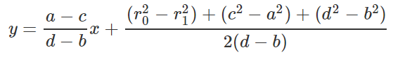

Intersection points of the two circles:



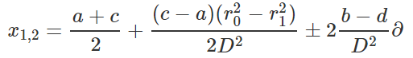

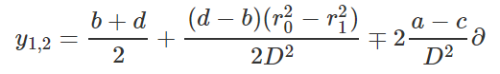

If the circles don’t intersect, the inverted line will be outside the inversion circle. First, we will find the coordinates of the point on the original circle that is farthest from the center of inversion. Now we will invert that point with respect to the inversion circle to find the point that passes through the inverted line. Finally, we will find the slope and equation of the inverted line that must be perpendicular to the line passing through the centers of the two circles.

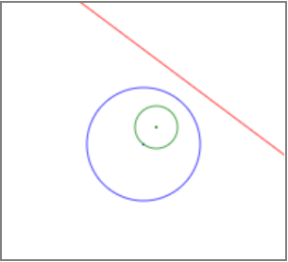

Find the point on the original circle that is farthest from the inversion center:





Invert that point to find the point on the inverted line:

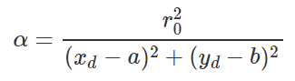





Calculate the slope of the diameter (rise/run):

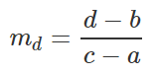

Calculate the slope of the inverted line (perpendicular):

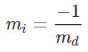

Calculate the intercept of the inverted line (y=mx+b):

 => 

Equation of the inverted line:



## Pappus Chain

The region bounded by the three semicircles is an arbelos, and the circles inside the arbelos is a Pappus chain (WolframMathWorld, 2017).

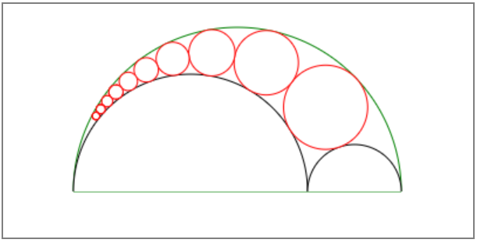

If *r* is the ratio of the radius of the big inner semicircle to the small one, the center and radius of the *nth* circle in the Pappus chain will be:

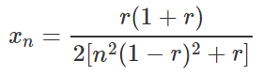

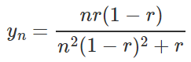

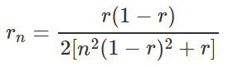

### Inversion of a Pappus Chain

The blue circle in the figure below serves as the inversion circle, and its center is the left corner of the largest semicircle. The two semicircles that pass through the center of inversion get inverted into lines.

The largest green semicircle is inverted into the green line on the left, while the left inner semicircle is inverted into the line on the right.

The red circles in the Pappus chain get inverted into the red identical circles between the two lines. The height from the center of the inverted circle *n* to the diameter line is *n* times its diameter (CutTheKnot, 2017).

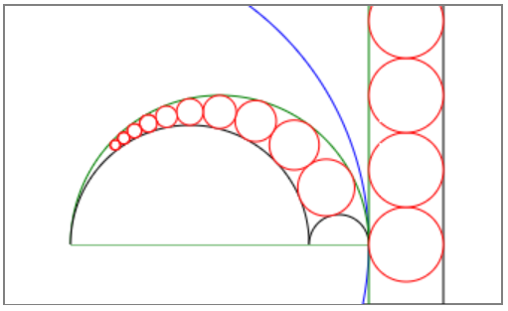

### Homothety

Homothety, also known as dilation or central similarity, is a transformation of a shape, which sends each point *M* on the original shape to a point *M′* on the line *OM* such that *OM′ = k.OM,* where *k* is a non-zero number (EncyclopediaOfMath, 2014).

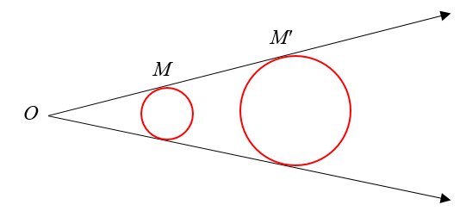

The point *O* is known as the center of homothety or center of dilation, and *k* is the homothety ratio or dilation factor. Two figures are called homothetic if they are positioned in such a way that a ray from point *O* to a point on the first figure contains the corresponding point on the second figure (Charles, R. I., Hall, B., and Kennedy, D., 2015).

# Materials & Methods

I used a MacBook Pro to develop a web page in HTML5 and JavaScript (JS). I wrote the source code in Brackets, an open-source text editor. This web page serves as a generic tool for circle inversion and Pappus chain. The user can invert a point or a circle with respect to an inversion circle. It can also be used to create a Pappus chain, invert the circles and semicircles, and show homothety between the circles in the Pappus chain, and their inversions.

On a standard coordinate system in math, (0,0) is the bottom-left corner, and the y-coordinate increases as you move up. On the contrary, a computer screen designates the top-left corner as (0,0), and the y-coordinate increases as you move down. Therefore, I converted the y-coordinate in my program by subtracting its value from the canvas height right before drawing a shape. This conversion made the canvas look more consistent with a math coordinate system.

I decided to create a simple user interface (UI) where people can easily play with circle inversion and Pappus chain by themselves. Since it would be inconvenient to scroll a long web page up and down, I used tabs to display several sections on top of each other in the same display area. I created a tabstrip with CSS classes in HTML5 without using JS (Martin Ivanov, 2017).

I used the HTML5 <canvas> tag to draw basic shapes such as points, lines, and circles. The <canvas> element has no drawing abilities as it is only a container for graphics. So, I used the getContext() method in JavaScript to return an object that provides methods and properties for drawing on the canvas (W3Schools, 2017).

Since I had three tabs laid out on top of each other, I used three separate canvases, one on each tab. The user can keep a template on each canvas in place while switching between them.

The web page has around 1,100 lines of code. Half of it is the HTML code for the UI design and interaction, while the other half is the JavaScript code to process user requests. Aside from the event listeners used to display the mouse positions, all the other functions are called by the click of a button on the page.

First, I wrote the utility functions to draw a point, a line, and a circle/semicircle based on the arguments passed into them. Then I wrote the inversion specific functions to make the necessary calculations and to draw the shapes by using the utility functions.

To make life easier for the end-user, I provided templates to load predefined data and invert automatically. In addition to these templates, I also allowed the user to enter custom values into the textboxes and invert on their own.

# Results

The web page displays three tabs to let the user invert a point, invert a circle, and create a Pappus chain, invert its parts, and show homothety.

## Inversion of a Point

The user can load a template with predefined settings with the click of a button, or enter their custom settings and click the “Invert” button to examine the inversion of a point.

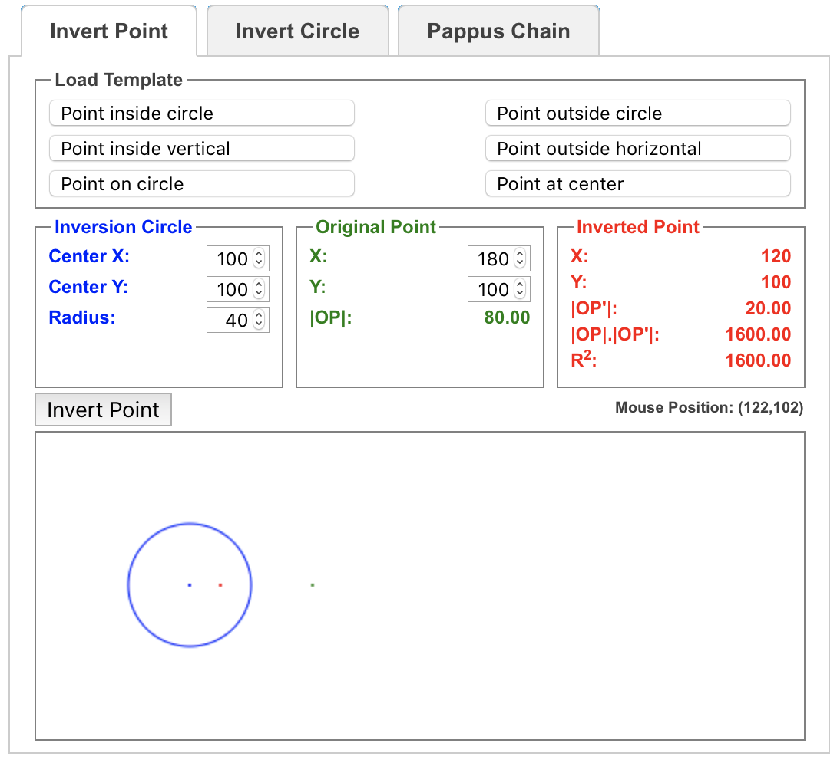

## Inversion of a Circle

The user can load a template with predefined settings with the click of a button, or enter their custom settings and click the “Invert” button to examine the inversion of a circle.

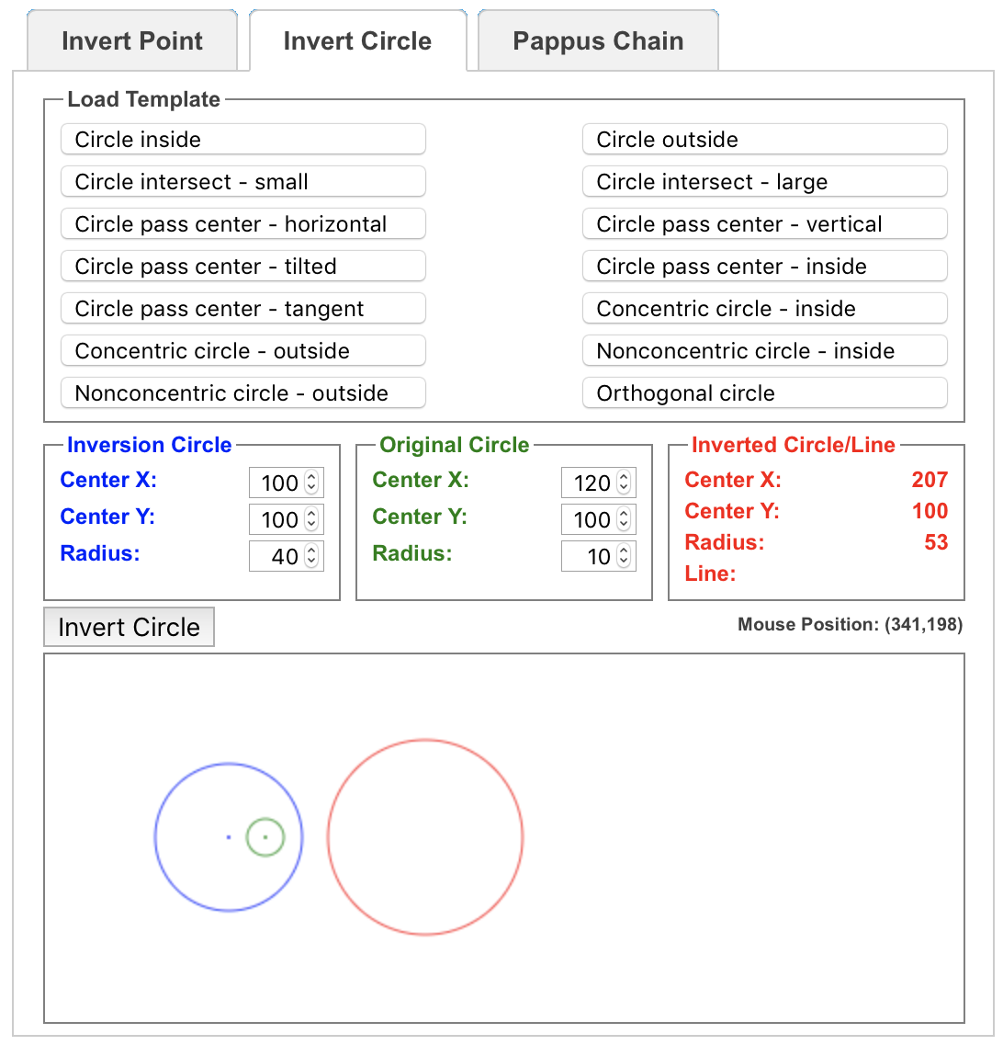

## Pappus Chain

The user can load a template with predefined settings with the click of a button, or enter their custom settings and click the “Create”, “Invert”, or “Homothety” button to examine the Pappus chain.

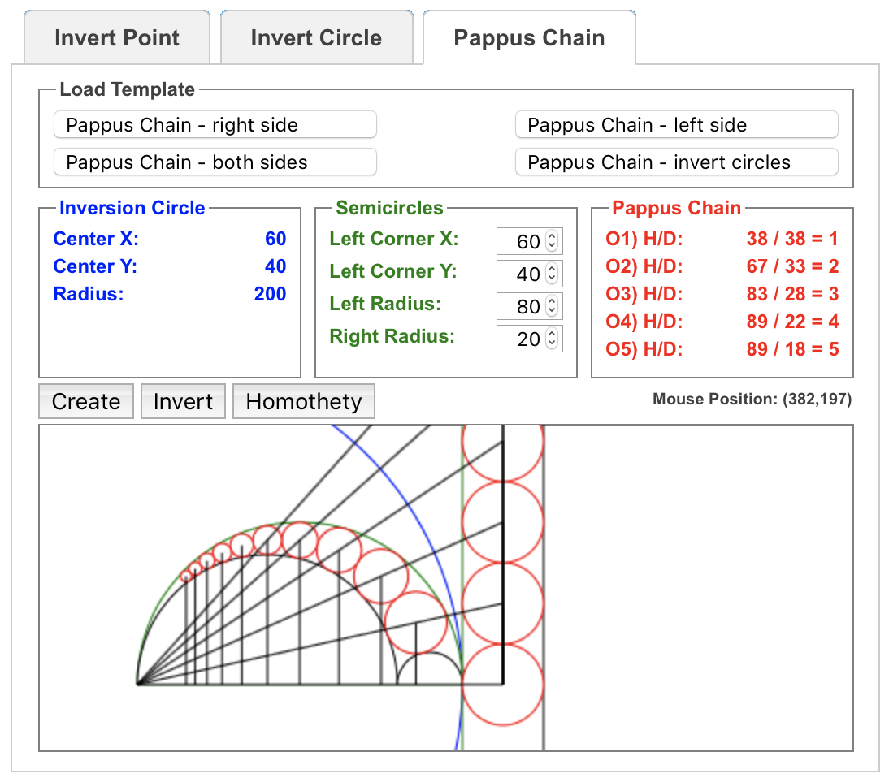

# Discussion

Each original circle in the Pappus chain and its inverted circle between the lines are homothetic with the center of homothety being the center of the blue inversion circle. Connecting the center of homothety to the center of original and inverted circles will create similar triangles as shown below.

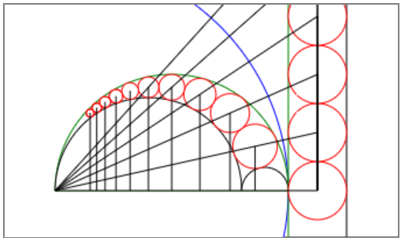

Let *dn* be the diameter and *hn* be the height from the center of the original circle *n* in the Pappus chain. Similarly, let *d'n* be the diameter and *h'n*be the height from the center of its inverted circle between the lines. Since the circles between the lines are identical, we can easily observe that:

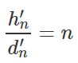

From similarity:

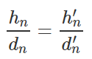

Therefore:

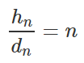

or



This simply proves Pappus’ theorem, which states that the height from the center of the *nth* inscribed circle in the Pappus chain is equal to *n* times the diameter of that circle.

# Conclusion

Circle inversion can be used to solve difficult problems such as proving Pappus’ theorem by visually showing similarity between circles and their inverted images. However, it may not be trivial to see the inversion without proper drawings and calculations.

Since it wasn’t practical to draw circles with various sizes and calculate their inversions on paper, I decided to develop a computer program with graphics features to draw basic shapes such as points, lines, and circles. This program let me simulate circle inversion and Pappus chain visually, while also showing the calculations.

First, I considered developing a Java program just to solve the given problem, but I quickly shifted my focus to website development so that other people could use it as a tool for further research. Even though a Java program could be turned into a Java applet to run on a web page, I faced security issues on several websites running applets. Besides, it would be harder to host my server code freely, and share the source code with others easily.

Because of the limitations of server-side coding, I decided to develop a web page in HTML and JavaScript with client-side coding. It runs in the latest browsers on all computers and mobile devices. It was also easy to have a single web page hosted for free.

I share this software application as an open-source tool with anyone interested in math, and specifically in circle inversion and Pappus chain. Please feel free to use the application and get the source code from my web page at <http://sukarablog.weebly.com>.

# Further Research

This project builds the basis for inverting a point or a circle with respect to an inversion circle. However, it can be extended to the inversion of other shapes to analyze the effects of circle inversion. It can also be improved to invert shapes and objects with respect to a sphere in 3-D since most of the equations will be very similar to 2-D.

# Acknowledgements

I’d like to thank *Mr. Wenk*, my advisor and geometry teacher, for reviewing my work. I appreciate *Brackets*, an open-source project for a powerful text editor, which I used to type my source code. I also thank *Weebly* for hosting my web page for free and making this tool available to others. Finally, I thank *HostMath* for their equation editor that I used to convert equations into nice images before inserting into this report.

# References

AmBrSoft, 2016, <http://www.ambrsoft.com/TrigoCalc/Circles2/circle2intersection/CircleCircleIntersection.htm>

Charles, R. I., Hall, B., and Kennedy, D., 2015, Geometry Common Core, Pearson, 587-593

CutTheKnot, 2017, <https://www.cut-the-knot.org/Curriculum/Geometry/InversionInArbelos.shtml>

EncyclopediaOfMath, 2014, <https://www.encyclopediaofmath.org/index.php/Homothety>

Martin Ivanov, 2017, <http://experiments.wemakesites.net/css3-tabstrip.html>

ScienceBuddies, 2017, <https://www.sciencebuddies.org/science-fair-projects/project-ideas/Math_p011/pure-mathematics/chain-reaction-inversion-pappus-chain-theorem>

Tom Davis, 2011, <http://www.geometer.org/mathcircles/inversion.pdf>

W3Schools, 2017, <https://www.w3schools.com/tags/ref_canvas.asp>

WolframMathWorld, 2017, <http://mathworld.wolfram.com/Inversion.html>